CURRICULUM VITAE  SILPY PATEL  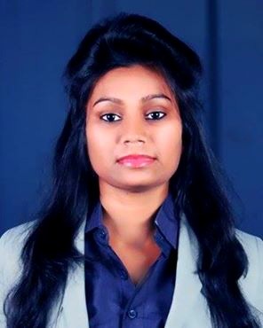  D.O.B. : 04/02/1992  Contact Information:  Mobile Contact No.:  + 91 8126597385  +91 9899670478  E-mail:patelsilpy22@gmail.com  Permanent Address: C/O Rameshwarsingh  Ward no.20, Bhabua, Kaimur  BIHAR, 821101  Current Address:  D-105 sector 27  Noida (U.P), 201301 | APPLYING FOR :- ( FINANCE SECTOR)  CAREER OBJECTIVE:-  To be pioneer and lead others with example in the industry. I believe conceive the vision, develop the plan, implement all details and co-ordinate diverse constituencies and motivate and lead all levels to operate towards the organization’s goals. I am interested in working with your reputable company so that I can utilize my academic and professional skills for the benefit of the company.  I wish to join your company because your company gives the opportunity so that I can progress in this field flawlessly.  I have been completed my PGDM JULY 2014 from DOON BUSINESS SCHOOL, DEHRADUN.  PROFESSIONAL QUALIFICATION:-  PGDM (MAJOR FINANCE & MINOR MARKETING) from DOON BUSINESS SCHOOL, DEHRADUN  ACADEMIC PERFORMANCE:-  SUMMER INTERNSHIP PROJECT:-  - Have done 45 days internship during PGDM at Hotel MAURYA, PATNA from 1stjuly to 15th august. Project Titled is “A Project report on WORKING CAPITAL MANAGEMENT”.
  COURSE |  | Post Graduation | Graduation | INTERMIDIATE | High school
  Institution |  | Doon Business School Global, Dehradun | Veer Kunwar Singh University,  ARA | R.S Secondary Education Councile Board Bihar  (BIHAR BOARD) | R.S.B. High School (Bihar Board)
  QUALIFICATION |  | PGDM  (finance) | B.Sc  (Mathmatics) | I.Sc
  YEAR |  | 2014 | 2011 | 2008 | 2006
  Performance |  | 63% | 65% | 63% | 67%

ACHIEVEMENTS

- Scored 53% at National IT aptitude Test (NIIT) 2013.
- Got 3rd Prize In Graduation For Secured 3rd Highest Marks In College.
- Got Merit Certificate In Class 12Th For Achieving Highest Marks In Math.
- Got 2nd Prize In Dance Competition In Inter College In2011.

COMPUTER SKILLS:

- Operating systems - windows 7/ windows 8/ windows xp
- Packages - ms office (word, excel &powerpoint), sap, tally & IDS

SPECIAL INTEREST:-

- LISTENING MUSIC, DRAWING, Cooking and Interior decoration

PERSONAL DETAILS:
- Gender : Female
- Language: Read Write Speak
- English √ √ √
- Hindi √ √ √
- French √ √ √

PERSONAL INFORMATION:-
FATHER’S NAME : MR. UMASHANKAR SINGH
MOTHER’S NAME : MRS. SATYA DEVI
NATIONALITY : INDIAN
MARITAL STATUS : UNMARRIED

REFRENCE-:

